Transistor SK100
CP015
Image:
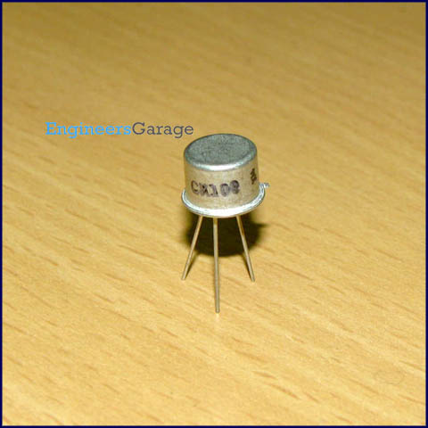
DataSheet:
SK100.pdf
SK100 is a general purpose, medium power PNP transistor. The basic applications of a transistor are switching, amplification and regulation. Its DC current gain ranges from 100 to a maximum of 300.

The transistor terminals require a fixed DC voltage to operate in the desired region of its characteristic curves. This is known as the biasing. For amplification applications, the transistor is biased such that it is partly on for all input conditions. The input signal at base is amplified and taken at the emitter. BC548 is used in common emitter configuration for amplifiers. The voltage divider is the commonly used biasing mode. For switching applications, transistor is biased so that it remains fully on if there is a signal at its base. In the absence of base signal, it gets completely off.
The emitter leg of SK100 is indicated by a protruding edge in the transistor case. The base is nearest to the emitter while collector lies at other extreme of the casing.

Pin Diagram:
